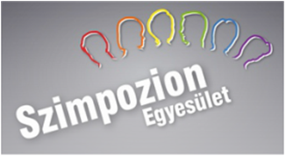

Szimpózium Association

Szimpózium Association was founded in 2002. Its aim is to work on helping LGBTQ people to stand up for themselves and assisting them on their journey of self-acceptance. The Association organizes several community programs for them, offering information on any relevant topics. Also, it is intended to reach the heterosexual majority to give an authentic portrayal of the life of sexual minorities and their goals.

Regularly club events and roundtable discussions are organized with guests, including renowned scientists, artists and other well-known persons. With the video blog, titled Through Gay Eyes, information is shared with both the LGBTQ community and heterosexuals, in order to dispel prejudices. Almost 160 episodes have been published so far concerning a variety of subject matters, including:

- topics of gay life (coming out, romantic relationship, physical-emotional health, old age, etc.);
- associations, groups and initiatives;
- LGBTQ events (e.g. Budapest Pride);
- personalities, activists and life stories;
- critically acclaimed short films.

Together with Labrisz Lesbian Association, the Association’s most important school programme (starting in 2001) is „Getting to know LGBT people”. Hundreds of hours have been held in secondary schools as well as in teacher training institutions allover Hungary.

Homepage of the program: http://melegsegesmegismeres.hu/.

http://www.melegvagyok.hu/szimpozion-association.html
www.facebook.com/szimpozion
www.facebook.com/melegszemmel

szimpozionegyesulet@gmail.com
www.youtube.com/user/szimpozion

